SCUBA-2 Block Specification
addr_card

Created on: 4 October 2005
Last saved on: 07 October 2005
Table of Contents

1. Block Description 3
1.1 Block Hierarchy 3
1.2 Block Overview and Features 3
1.3 Detailed Description 3
2. Interface Description 5
2.1 Signals Description 5
Files Associated with this Block 7

Block Description
The addr_card is the top-level block in the hierarchy of the RTL-level code for the Address-card FPGA.

Block Hierarchy
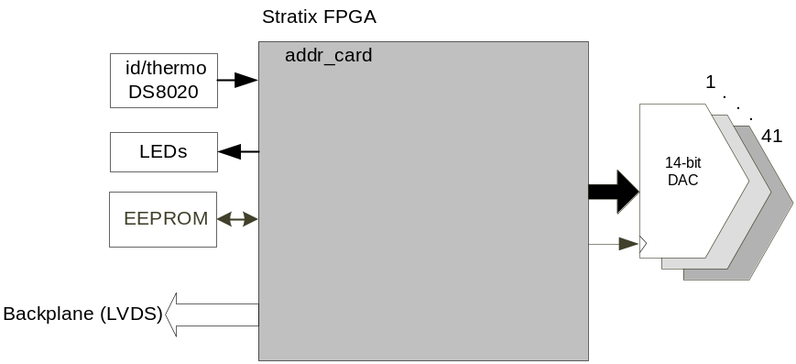
Figure 1: addr_card Block Location Within the System

Block Overview and Features
The addr_card top level communicates to the external devices including the 41 parallel DACs, LEDs, id/thermo chip, and EEPROM.

Detailed Description
The Wishbone bus protocol (refer to Wishbone Specification) is adopted as inter-block communication standard between the different blocks in addr_card. One block, in this case dispatch, acts as Wishbone Master and the other blocks are Wishbone slaves. Commands are received along the backplane LVDS line and then decoded by the Wishbone Master and communicated to the relevant Wishbone Slave through the Wishbone protocol.
The following blocks are instantiated in addr_card block:
- ac_dac_ctrl:
  - This block controls all the parallel DACs.
- frame_timing:
  - This block controls the overall timing and ensures the coherence of the operations of the different blocks.
- dispatch:
  - Receives and decodes the incoming backplane commands
  - Delivers the wishbone-formatted command to the appropriate wishbone slave
  - Converts the wishbone reply to backplane format and transmits the reply over the backplane.
- id/thermo: A wishbone slave to read the card-id and the temperature from the DS8020 chip
- leds: A wishbone slave to controls the 3 LEDs
- fw_rev: A wishbone slave to return the firmware revision
For more information, refer to the documentation for each block.

addr_card
frame_timing
ac_dac_ctrl

ac_dac_ctrl_core
leds
dispatch
ac_dac_ctrl_wbs
fw_rev
id_thermo

Figure 2: addr_card Block Diagram

Interface Description

Signals Description
 | Description | Direction
Global Signals
rst_n | Global reset signal | In
Inclk | PLL input clock | in
Interface to Parallel DACs
dac_ data0 | 14-bit data for the parallel DAC shared between 4 DACs | out
dac_ data1 | 14-bit data for the parallel DAC shared between 4 DACs | out
dac_ data2 | 14-bit data for the parallel DAC shared between 4 DACs | out
dac_ data3 | 14-bit data for the parallel DAC shared between 4 DACs | out
dac_ data4 | 14-bit data for the parallel DAC shared between 4 DACs | out
dac_ data5 | 14-bit data for the parallel DAC shared between 4 DACs | out
dac_ data6 | 14-bit data for the parallel DAC shared between 4 DACs | out
dac_ data7 | 14-bit data for the parallel DAC shared between 4 DACs | out
dac_ data8 | 14-bit data for the parallel DAC shared between 4 DACs | out
dac_ data9 | 14-bit data for the parallel DAC shared between 4 DACs | out
dac_ data10 | 14-bit data for the parallel DAC shared between 4 DACs | out
dac_clk | 41-bit clock for DAC0 to DAC40 with each bit being the clock for one of the DACs | out
LVDS Interface
lvds_cmd | receives incoming commands over the backplane LVDS line. The backplane signal is a multi-drop signal that originates from clock card and goes to all the cards. | in
lvds_sync | incoming sync signal over the backplane LVDS line | in
lvds_spare | connected to a spare backplane LVDS line for future use | in
lvds_txa | used to transmit the reply to a command over a backplane LVDS line. The backplane line is a dedicated line between readout card and clock card. | out
lvds_txb | connected to a spare backplane LVDS line for future use. The backplane line is a dedicated line between readout card and clock card. | out
EEPROM Interface
eeprom_si | Incoming serial data from eeprom as part of the SPI interface | in
eeprom_so | Outgoing serial data to eeprom as part of the SPI interface | out
eeprom_sck | Serial clock for eeprom (SPI interface) | out
eeprom_cs | Chip select for eeprom (SPI interface) | out
TTL Interface (X 3 for TTL1 to TTL3 spare lines)
*Note: Clock card uses ttl1 line to send down the global firmware reset to all the cards
ttl_txena1 | controls the direction of the spare TTL line | out
ttl_nrx1 | input TTL spare line controlled by ttl_txena1 | in
ttl_tx1 | output TTL spare line controlled by ttl_txena1 | out
LED Interface
red_led | Red LED data | out
ylw_led | Yellow LED data | out
grn_led | Green LED data | out
Miscellaneous
dip_sw3 | dip switch 3 data | in
dip_sw4 | dip switch 4 data | in
wdog | watchdog | out
slot_id | 4-bit data hard-wired per slot on the backplane | in
card_id | single-wire interface to the on-board ds8020 id/temperature chip | in
test | 32-bit PTH test header | out
mictor | 32-bit data for the logic analyzer | out
mictorclk | 2-bit mictor clock pins for the logic analyzer | out
rs232_rx | Debug port | in
rs232_tx | Debug port | out

Files Associated with this Block

File | Description
addr_card.vhd | top-level
addr_card_pack.vhd | pack file for addr_card.vhd including definition of some of the constants
packet.hex | used to emulate backplane-format commands in conjunction with tb_addr_card_self_test.vhd
tb_addr_ card_self_test.vhd | testbench for addr_card top-level using packet_hex to emulate backplane commands
tb_addr_card.vhd | Testbench for addr_card top-level using a clok_card instantiation to emulate backplane commands.

